Experimental Testing of Prototype with Novel Propulsion System that rotates continuously while propelling forward

J. Botha[1]

Independent Researcher, Pretoria, Gauteng, 0181, South Africa

This study presents the development and experimental testing of a novel drone (“Droverbot”) prototype. The droverbot is equipped with a novel propulsion system (a.k.a. “Bot Drive”) that rotates the entire droverbot continuously, which is integral to the forward propulsion, causing all the thrusters fitted to the droverbot - when active - to curve ejected fluid continuously. The video footage allows for visual observation of the prototype’s novel method of forward propulsion on a horizontal surface and the integrated data logger provide quantitative data. The results show that the droverbot prototype propels forward while rotating continuously and curving ejected fluid continuously.

# Introduction

T

he use of drone technology, has increased significantly in recent years, with applications ranging from military and surveillance to agriculture and delivery services. In terms of drone designs, there are two main designs for drones: rotorcraft (like quadcopters that use four motors) and those that use wings and motor(s) (fixed-wing drones). [1]

The existing designs like quadcopters, as the name suggests, use four motors to provide lift and control and fixed-wing drones, on the other hand, use wings to provide lift and require a motor to provide forward thrust.

This study introduces the development and testing of a droverbot prototype using a novel propulsion system design. It is a motor-driven (but not limited to) propulsion system, referred to as a thruster. A thruster consists of an electric motor coupled with a propeller. The droverbot uses eight thrusters that are arrange on an octagon shape frame (four thrusters that spin on the horizontal plane) with two inner rods in the shape of a cross (also with four thrusters that spin on the horizontal plane) that connects two opposite sides of the octagon frame. Forward thrust is generated by rotating the entire droverbot continuously by using force couples for rotational motion and then, while the vehicle is rotating, to make use of variable force vector addition for forward propulsion. The introduction of the droverbot is presented on a flat horizontal surface. The study aims to introduce a droverbot prototype with a novel propulsion system by using video analysis and integrated data logging. The findings of this study could also contribute to the development of new droverbot propulsion systems with novel applications.

The primary objective of this study is to introduce the droverbot with a novel propulsion system that rotates the entire drone continuously while propelling forward and curving ejected fluid continuously.

In addition to introducing this droverbot prototype with a novel propulsion system, this study also aims to contribute to the development of new droverbots with this novel propulsion system design as a base. The findings of this study could provide insights into the design of new droverbots with this novel propulsion system as a base for various novel applications and environments.

Overall, the research objectives of this study are to introduce a novel prototype drone with a novel propulsion system design and to contribute to the development of new drone propulsion systems.

# Literature Review

The field of drone technology has seen significant advancements in recent years, however, the two current mainstream designs. like rotorcraft and fixed-wing drones still dominates. [1]

This study presents a novel drone prototype with a novel propulsion system design, which aims to introduce a possible third mainstream design.

Previous research literature on rotorcraft and fixed-wing drones provides valuable insights into their respective strengths and limitations, enabling researchers and practitioners to select the most appropriate type for specific applications. Rotorcraft, like quadcopters are preferred for tasks that require hovering and maneuvering in tight spaces, such as inspection and surveillance of buildings and infrastructure. In contrast, fixed-wing drones are suitable for longer-range flights and mapping applications that require high-speed and long-endurance flights. Also, a newly emerging trend of drone design is focusing on the integration of rotorcraft and fixed-wing drones, which can enable efficient and flexible operation in complex environments.

The novel drone (droverbot) prototype with a novel propulsion system introduced in this study could become another mainstream design. The prototype will demonstrate on a horizontal surface, that while the entire droverbot is rotating, it can propel forward. Because it propels forward in this manner, it has unique properties compared to the other mainstream drones. The findings of this study could contribute to the development of new drone propulsion systems based on the droverbot that are capable of:

1. movement along any axis, in any direction on that axis when a droverbot unit function alone.
2. movement along a combination of axes, meaning backward, sideways, diagonally, upwards, downwards or even rotating in place, when multiple droverbots’ units are attached to a common frame (kind of like how wheels are attached to a car), on all three axes and functioning together.
3. the droverbot are able to scale by adding multiple droverbot units together to a common frame, with the common frame design limiting the scalability.
4. using its thrusters to cause forward propulsion and rotational motion (the re-action force on the droverbot), while ejecting fluid (action force) from these thrusters are continuously curved and distributed as the droverbot rotates.

The implications of this novel propulsion design with these unique properties have the potential to introduce many novel applications in various environments as well as an alternative to the other two mainstream designs and the environments they function in.

Overall, this literature review highlights the two existing mainstream drone designs and elaborate on the droverbot and its unique properties of propulsion. The droverbot prototype presented in this study could contribute to this field by providing many potential novel applications in various environments that are unique as well as an alternative to the other two mainstream designs.

# Methodology

## Conceptual Design

The design was approached using an iterative experimental approach. This approach allowed for a dynamic and flexible design process, where adjustments and refinements were made based on empirical observations and feedback from initial experimental tests.

The conceptual design was the result of previously refined ideas identified that had the realistic potential to be translated into a novel drone prototype. With the translation of these ideas, previously practical knowledge gained together with thought experiments were considered until a physics compatible, engineered design was derived. From thereon, the emphasis was placed on conducting real-world experiments to evolve and validate the design.

With the experimental approach, earlier prototypes were assessed on how to make rotational motion and linear motion to occur simultaneously that will result in forward propulsion.

For the purpose of experimentation, it was decided that forward propulsion could either be horizontal on a surface or vertical into the atmosphere.

Horizontal forward propulsion was chosen due to several reasons:

1. Conducting the experiments on a horizontal surface does not limit the physics concepts involved to validate the novel propulsion system, since the droverbot will use the same physics concepts when propelling along any of the axes.
2. Observing activity of the droverbot and its thrusters was deemed easier than with vertical flight.
3. Less complexity and constraints compared to vertical forward propulsion where the full effect of gravity must be taken into account.
4. With vertical forward propulsion, due to experimental testing, if the prototype malfunctions in-flight it could lead to loss of prototype due to fall damage and that could result in unnecessary delays and costs.

Since the droverbot expel fluid via propellers it should be capable of flight with further improvements in efficiencies, using the physics concepts as introduced by this study.

To be able to make the prototype propel horizontal on a surface, the prototype was fitted with omni-directional trolley wheels. Enough clearance between the surface and propellers were allowed.

Prototypes were built with components deemed fit for the purpose, followed by series of tests. Observations of motion led to refinement of components, refinement of where to place the components on the prototypes as well as the refinement of the guidance system’s program code. Over time, data logging and video analysis were added to provide more feedback.

The integrated data logger recorded input from two components, the multi-function Adafruit BNO055 component and a real-time clock. The recorded data is the droverbot’s position relative to the Earth’s coordinate system. (Euler angles for Roll, Pitch and Yaw), the rate of rotation around three axes, Z, Y and X as well as time. Other measures were also available but were excluded due to memory constraints on the Arduino Nano “flash memory”. Video footage was used to evaluate thruster activity during tests.

The experimental approach led to the droverbot that was evaluated to be adequate for introducing a novel drone capable of forward propulsion while the entire droverbot rotates. Fig. 1, Fig. 2 and Fig. 3 below depicts some of the different stages of development of the droverbot as it matured.

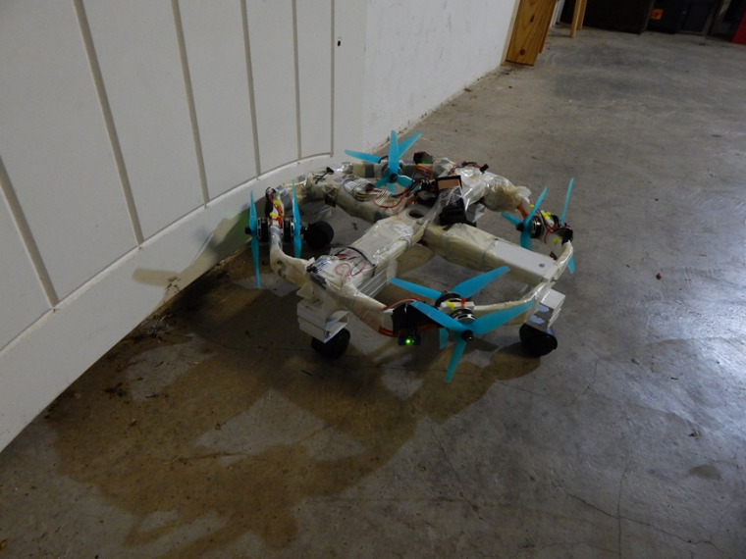

Fig. 1 Early stage of the droverbot development which shown opposite thrusters only on the octagon shape frame.

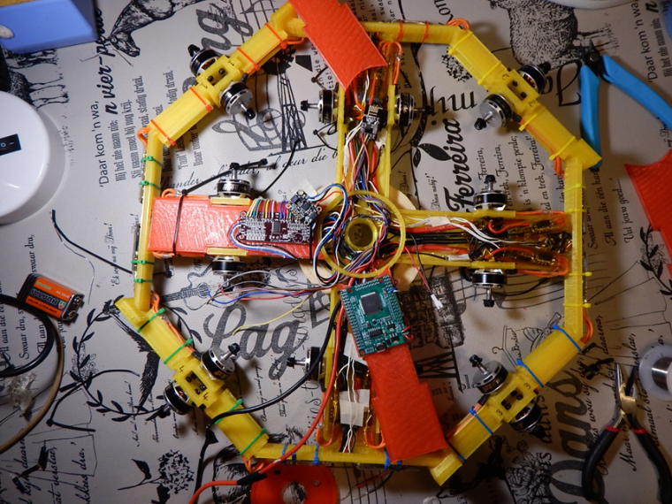

Fig. 2 This stage 16 motor were opted for (8 on octagon frame and 8 on the two rods) to create a testbed for many different combinations.

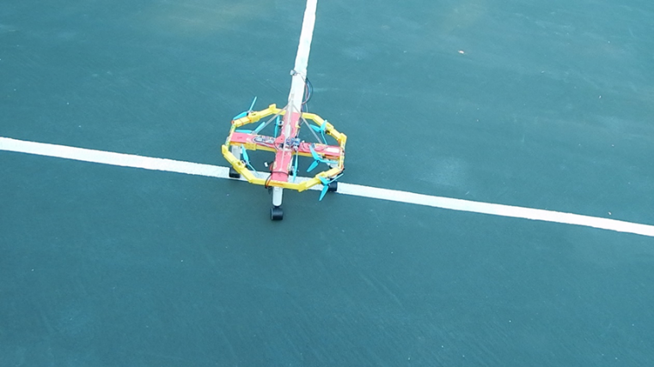

Fig. 3 The evolved experimental droverbot design chosen for this study with 4 thrusters on the octagon frame and 4 thrusters on the two rods.

## Structural Components

### Droverbot components

Fig. 4, Fig. 5 and Fig. 6 indicate the location of the components on the droverbot listed below.

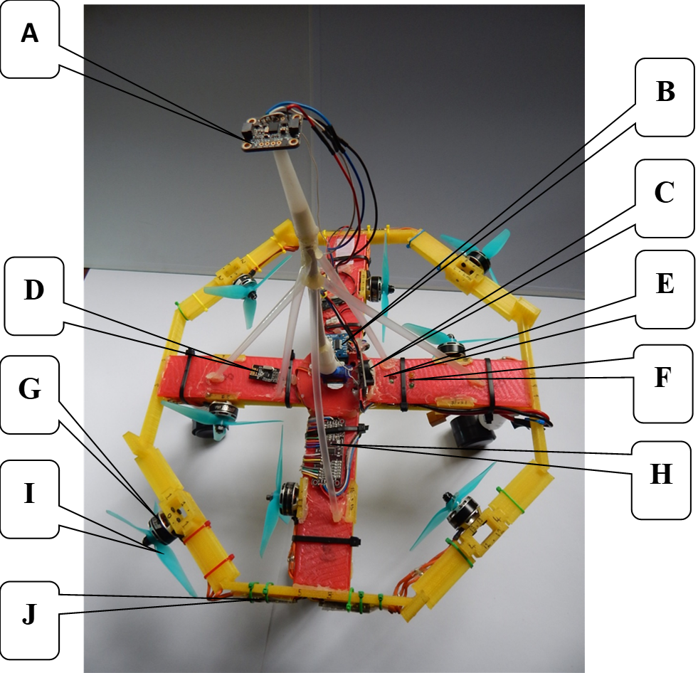

Fig. 4 Top view of droverbot.

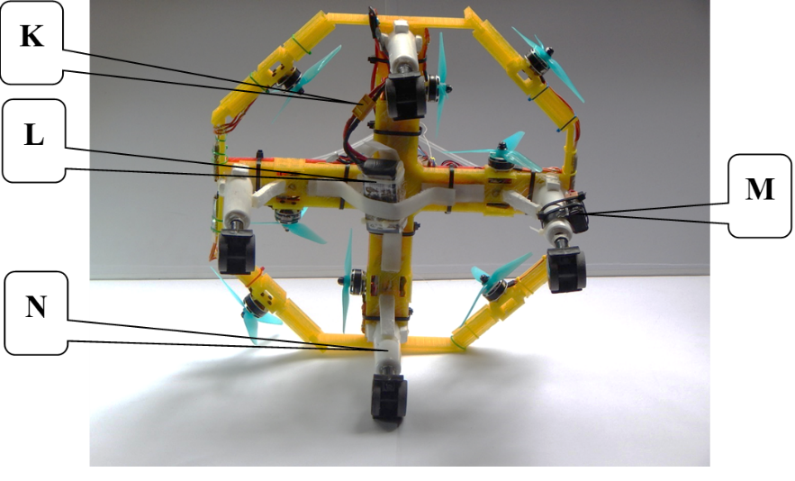

Fig. 5 Bottom view of droverbot.

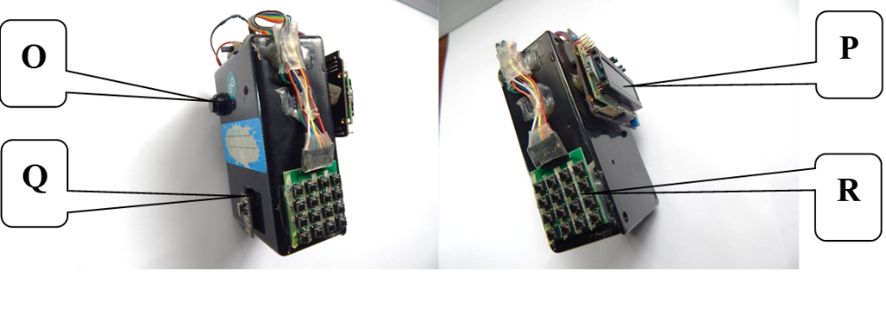

Fig. 6 Remote control.

1. **Adafruit BNO055 9-DOF Absolute Orientation IMU Fusion Breakout board**

This component integrates an accelerometer, gyroscope, and magnetometer sensors to provide orientation and motion sensing capabilities in a three-dimensional space. It also includes built-in sensor fusion algorithms that can output various motion measurements, but in particular, orientation data in Euler angles for heading, roll and pitch. (See Adafruit BNO055 datasheet <https://cdn-shop.adafruit.com/datasheets/BST_BNO055_DS000_12.pdf> ). As discussed earlier in the conceptual design, as the prototype evolved, refinements were made to placement of components. One of these refinements was the placement of this sensor. This sensor was elevated 20 cm above the droverbot frame, at the centre of the droverbot. The elevation is needed to ensure that the magnetometer of the sensor is not affected by the magnetic fields generated by the thrusters eight brushless motors.

1. **Adafruit MicroSD card breakout board**

The SD Card Reader will record data on a SD Card when the droverbot starts to move. The data is stored in a CSV file [2] format and contain the following fields of data:

### Date and Time

### Orientation data on X axis in the format of Euler angles (position relative to the Earth’s coordinate system; Tait-Bryan XYZ sequence)

### Orientation data on Y axis in the format of Euler angles (position relative to the Earth’s coordinate system; Tait-Bryan XYZ sequence)

### Orientation data on Z axis in the format of Euler angles (position relative to the Earth’s coordinate system; Tait-Bryan XYZ sequence)

### The rate of rotation on Z axis in the format of degrees per second; ZYX sequence

### The rate of rotation on Y axis in the format of degrees per second; ZYX sequence

### The rate of rotation on X axis in the format of degrees per second; ZYX sequence

1. **DS3231 I2C RTC Clock**

The real-time clock provides date and time data which is recorded on a SD Disk (See B above).

1. **nRF24L01 transceiver**

This transceiver is used to communicate to the transceiver located on the remote-control.

1. **Arduino Nano**

The Arduino Nano is embedded in a rod and functions as the central processing unit on the droverbot.

1. **LED lights**

Three LEDs are connected to the Arduino Nano. They are used to provide feedback about the calibration ready status of the Adafruit BNO055 component before the droverbot is activated to propel.

1. **T-Motor F40III KV: 2600**

Eight of these motors are attached to the droverbot frame and together with eight propellers they form the eight thrusters. See specifications of these motors in Ref. [3].

1. **Adafruit PCA9685 16-channel PWM Servo Driver**

The PCA9685 servo driver is used together with eight HGLRC Forward ESC’s to drive the eight thrusters.

1. **Model#:R38-BL-PC HeadsUp Racing Prop R38 (2CW+2CCW)-Poly Carbonate**

Eight three-blade propellers each attached to a T-Motor on the droverbot and together they form the eight thrusters.

1. **HGLRC Forward FD50A ESC**

Eight HGLRC Forward ESC’s control the eight thruster motors. The HGLRC Forward ESC’s were configured with the software utility BLHeli32. The BLHeli32 configuration was setup in such a way that all eight thruster motors have been configured exactly the same. BLHeli32 was used to setup a configuration that allow ESCs and PCA9685 controller to work together to control the thruster’s motors. [4]

1. **Male and Female Connector Plugs**

Connector plugs connects the TAttu R-LINE 1550 mAh 120C battery with the eight HGLRC Forward ESC that drive eight thruster brushless motors. 12 AWG wire is used to handle high drawn ampere.

1. **TAttu R-LINE 1550 mAh 120C Version 3.0 Battery**

This battery is used to power the ESCs and thruster motors.

1. **9-VOLT Battery**

This battery is used to power the Arduino Nano and all other electronics (except ESCs and thruster motors).

1. **Omni-trolley wheels with legs**

These trolley wheels are used to allow the droverbot to move horizontal on the surface, in any direction.

1. **Remote control reset button**

This button is connected to the embedded Arduino Mega inside the remote-control and is used to reset the remote control if needed.

1. **Remote control LCD display**

The LCD gives visual feedback of the button pressed on the remote control keypad. (See R below)

1. **nRF24L01 transceiver**

This transceiver is used to communicate to the transceiver located on the droverbot.

1. **Remote control keypad**

Only one button was used in this study to activate the drone remotely.

### Droverbot Frame Design and Fabrication

The droverbot frame design was approached using an iterative experimental approach as describe earlier in the Conceptual Design. This approach allowed for a dynamic and flexible design process, where adjustments and refinements were made based on empirical observations and feedback from initial experimental tests. Earlier iterations of the frame were built from carton box as well as plastic (not 3D printed). Earlier shapes of the frame were circular but was abandoned in favor of an octagon shape as it allowed tighter and more precise mounting of the thruster motors. Preferring the octagon shape above the circular shape had no impact on the rotational motion, as an octagon shape can also spin around its center (a.k.a. the centroid). The current droverbot frame is rigid and was designed to accommodate the selected propulsion system components while minimizing weight and to limit impact on the flow of air generated by the propellers. The frame was designed using CAD software, and then 3D printed using PVA plastic. Several iterations later, the final drone frame used in this study – with components - had a total weight of 1392 gram (including total weight of batteries - 226 gram (Tattu R-line battery 181 gram plus 9-volt battery 45 gram). The apothem of the octagon frame is 20 cm. The side length 15.5 cm. The height and width of the octagon sides varies. The height and width are 2cm and 0.5cm respectively - with no thruster mounted - to where thrusters are mounted on the sides, the height is 1.1cm and the width 2cm. The section of the sides where the thruster is mounted – the casing - the height is 2.5cm and the width is 2cm. The rods’ height without the lids are 1.1cm and the lids are 0.3cm. The rods’ width are 4.5cm and length are 15cm. The hub at the center of the octagon shape have a diameter of 7.5 cm with the opening at the centroid of the octagon shape, with a diameter of 2.2cm where an axle could fit in. Fig. 7 below shows the covers lifted from the octagon frame rods, that exposes the wiring as well as the embedded Arduino Nano and nRF24L01 transceiver. Fig. 8 show a top-down view of the octagon shape frame of the droverbot, with the two rods in the shape of a cross (red) connected to the octagon frame (yellow). Fig. 9 shows a bottom view of the droverbot. Note - at the center of the droverbot is a hub (as pointed by A), where an axle can be fitted at the centroid position of the octagon. This allow the droverbot to be connected to an external frame much like wheels are connected to the body of a car.

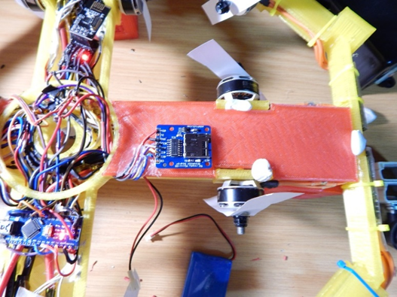

Fig. 7 Covers lifted from rods showcasing the wiring of the droverbot

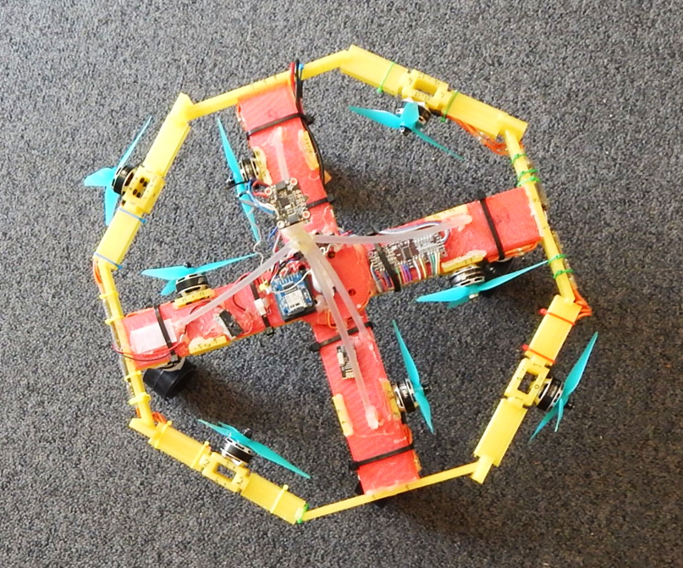

Fig. 8 Top view of droverbot.

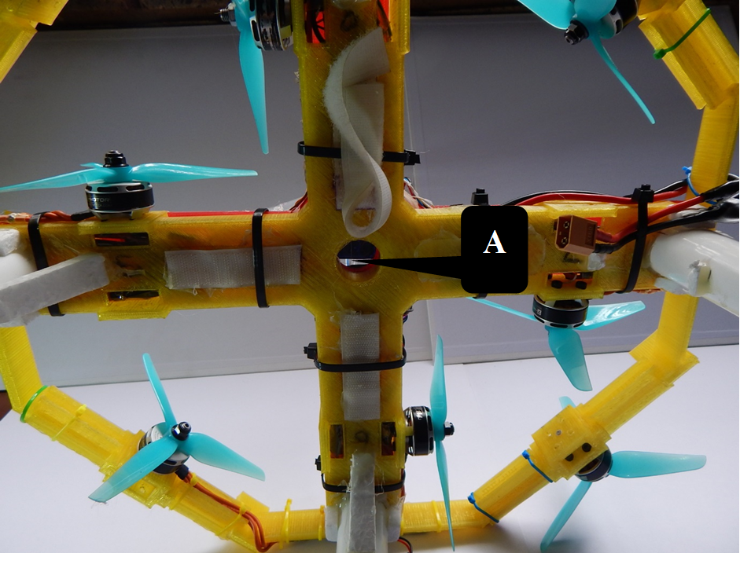

Fig. 9 Bottom view of droverbot with hub for an axle.

# Propulsion system

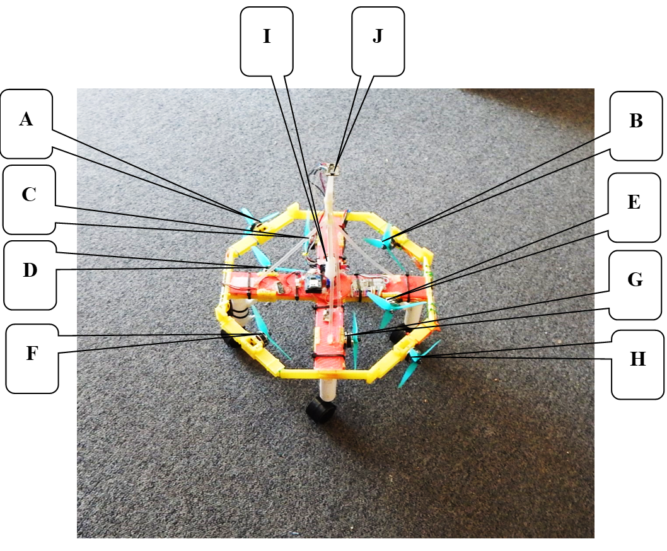

Fig. 10 The basic design of the propulsion system

In Fig. 10, two thrusters are located on each rod (Fig. 10 - D & E and Fig. 10 - C & G) that produce rotational motion in opposite directions (clockwise and anti-clockwise, respectively) by being implemented as force couples. On the octagon frame four thrusters (Fig. 10 – A, B, F and H) produce forward propulsion by implementing variable vector addition as the droverbot rotates. (Various combinations of these thrusters can produce forward propulsion in various directions and will be explained in detail in section VI. Results and Analysis)

Located at the center of the propulsion system and elevated, is a multi-function Adafruit BNO055 sensor (Fig. 10 - J). This sensor measures the orientation angle of the propulsion system in three-dimensional space. This positional feedback data is provided as input to the Arduino Nano (Fig. 10 – I), which is embedded inside the rod.

The Arduino Nano takes input from Adafruit BNO055 sensor to control all of the eight individual thrusters via program code.

## Rotational Motion

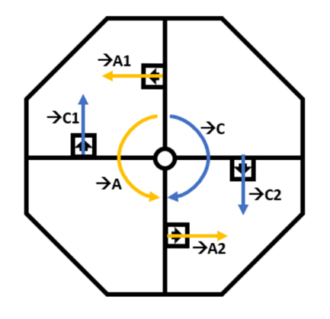

**B**

**A**

Fig. 11 Rotational Motion Schematic

Rotational motion is created by equal thrust generating thrusters located on the same rod - mounted on the horizontal plane - facing opposite directions of each other and equal distance from the center of the octagon frame. This is also known as a force couple. See Fig. 11, A and B. The squares indicate the thruster units. The arrows inside the squares indicates the direction of the thrust. Fig.11A thruster units will rotate the droverbot clockwise. Fig.11 B thruster units will rotate the droverbot anti-clockwise. When the droverbot is rotating clockwise as shown in Fig.11 with thrusters shown by A, the thrusters shown by B (opposing set of thrusters) will be able to slow down or stop the clockwise rotation with anti-clockwise thrust and vice versa. This mechanism result in a rotational lever, that is, to be able to control rotational speed and rotational acceleration of the droverbot.

To be more specific, initially, the set of thrusters that causes clockwise rotation will have a setting value that produce more thrust than the set of thrusters that causes anti-clockwise thrust, therefore the drone will rotate clockwise. The setting value were then adjusted several times during a 360°turn, based on ‘degrees turned over time’, that will make one set of thrusters on a rod produce more or less thrust than the other set of thrusters on another rod.

## Translational Motion

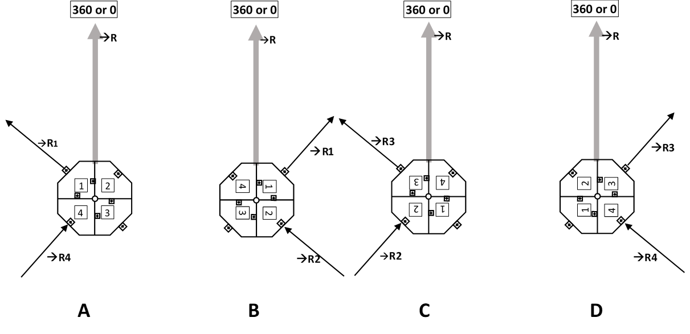

Fig. 12 Pairs of vectors representing thrusters on droverbot at A, B, C and D. 🡪R, the resultant force (or heading) represent the chosen degree 360 or 0. Quadrants are marked 1,2,3 and 4.

Translational motion in a chosen direction is created with a pair of selected thrusters – via vector addition - that are executed at the same time for the same duration. The combination of the vector pairs, 🡪R1 and 🡪R4, 🡪R1 and 🡪R2, 🡪R3 and 🡪R2 and 🡪R3 and 🡪R4, represent the thrust generated by thrusters as shown in Fig. 12 A, B, C and D. Each pair have a resultant vector,🡪R, which unify motion into a single direction.

Below is a more detailed explanation on a rotation interval of 90 degrees, as depicted in Fig. 12

1. In Fig. 12 A, Quadrant 1 outside thruster – degree 315;🡪R1 - work together with Quadrant 4 inside thruster – degree 225;🡪R4 - to produce Resultant force 🡪R. Quadrant 2 and Quadrant 3 thrusters are inactive.

When the droverbot rotate clockwise 90 degrees from position A, the orientation will result in position B.

1. In Fig. 12 B, Quadrant 1 outside thruster – degree 45;🡪R1 - work together now with Quadrant 2 inside thruster – degree 135;🡪R2 - to produce resultant force 🡪R. Quadrant 4 thruster is now in-active as well as Quadrant 3.

When the droverbot rotate clockwise 90 degrees from position B, the orientation will result in position C.

1. In Diagram Fig. 12 C, Quadrant 3 outside thruster – degree 315;🡪R3 work now together now with Quadrant 2 inside thruster– degree 225;🡪R2 - to produce resultant force 🡪R. Quadrant 1 thruster is now in-active as well as Quadrant 4.

When the droverbot rotate clockwise 90 degrees from position C, the orientation will result in position D.

1. In Diagram Fig. 12 D, Quadrant 3 outside thruster – degree 45;🡪R3 - work now together now with Quadrant 4 inside thruster – degree 135;🡪R4 - to produce resultant force 🡪R. Quadrant 2 thruster is now in-active as well as Quadrant 1.

When the droverbot rotate clockwise 90 degrees from position D, the orientation will result in position A and the cycle repeat again. It is also possible for the droverbot to rotate anti-clockwise at 90 degrees from diagram A to D, D to C, C to B and B to A. Fig. 13 below shows an illustration of color-coded pairs of vectors that work together - vector addition - depicting magnitude and direction at an interval of every 15° on the droverbot, while rotating (clockwise or anti-clockwise), causing constant linear motion in the direction of the resultant force, 🡪R.

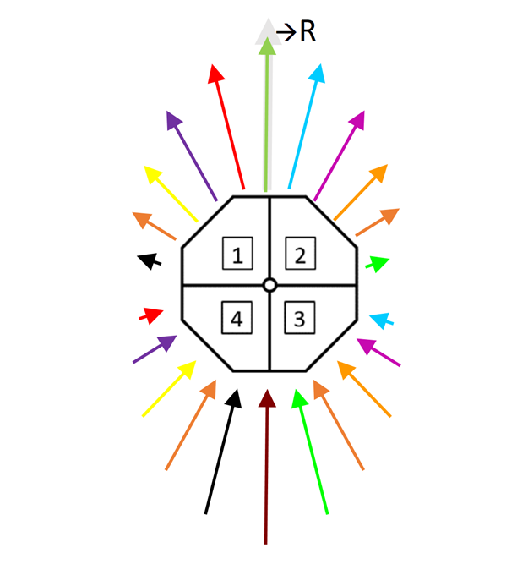

Fig. 13 An illustration of color-coded pairs of vectors that work together via vector addition to cause constant linear motion in the direction of resultant force, 🡪R.

## Linear motion with rotation

Fig. 14 below indicate how rotational motion together with translational motion functions together to cause “linear motion with rotation”, also known as “spinning translational motion” when an object move along a surface. As the droverbot rotates these pairs of vectors (representing thrusters on the octagon frame) varies in magnitude and direction given the degree of rotation, to cause the resultant force 🡪R. Fig. 14 depicts 180 degrees of rotation - clockwise at an interval of 15 degrees - of the droverbot while showing vectors with varying magnitude and direction.   
Below follows a description of Fig. 14 at intervals of 45° in terms of thrust strength.   
At degree 0, 🡪R1 is at 100% strength and 🡪R2 at 0% strength. At degree 45, 🡪R1 is at 50% strength and 🡪R2 is at 50% strength. At degree 90, 🡪R1 and 🡪R3 is at 0% strength and 🡪R2 is at 100% strength. At degree 135, 🡪R3 is at 50% strength and 🡪R2 is at 50% strength. At degree 180, 🡪R3 is at 100% strength and 🡪R4 at 0% strength.   
🡪R is always consistent at 100% strength. (The vectors of the rotational thrusters on the rods were excluded on purpose to avoid clutter on the diagram.)

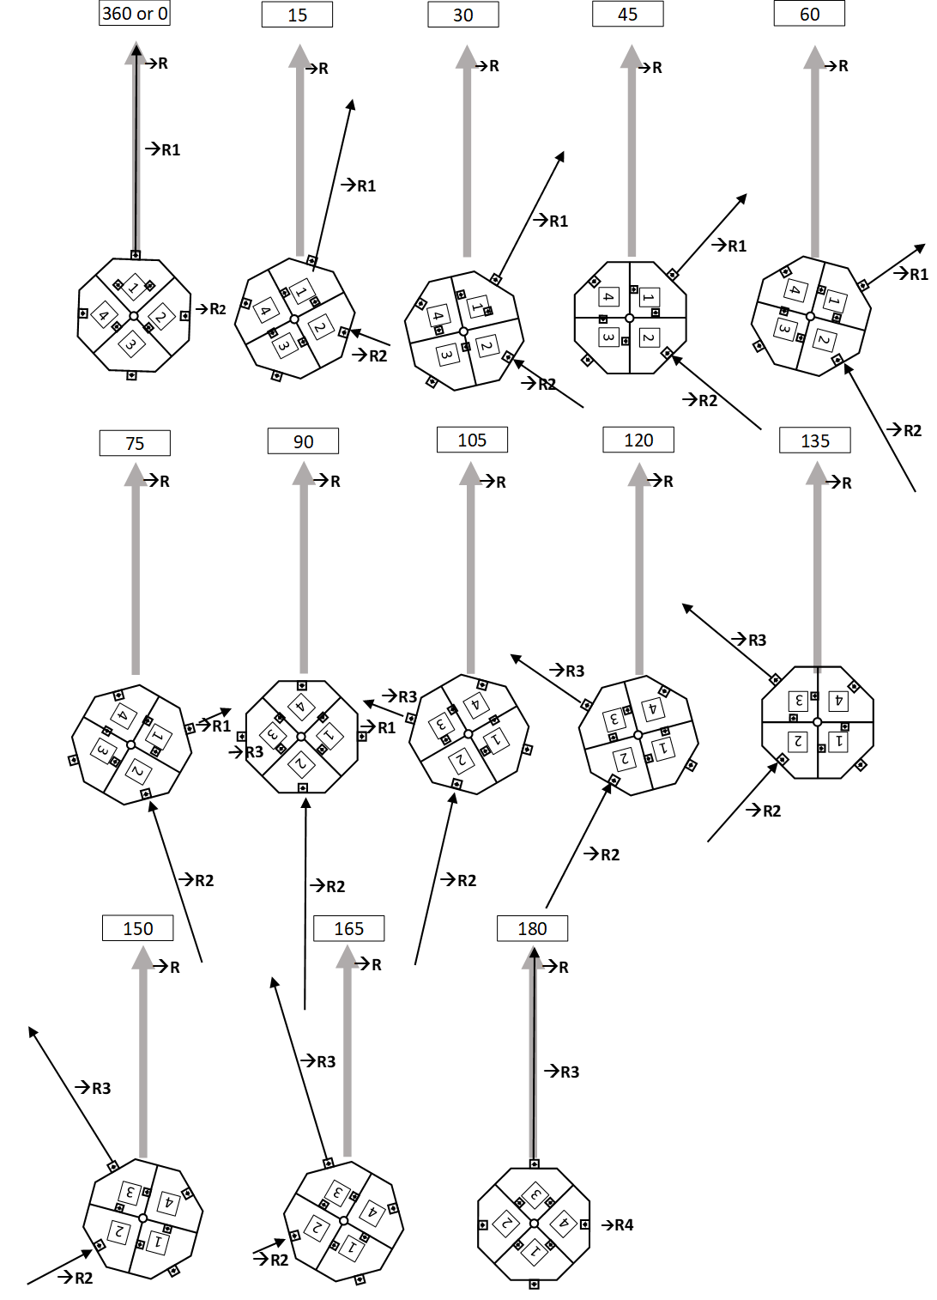

Fig. 14 With every 180 degrees of rotation, the vectors in magnitude and directions repeat.

# Experimental Setup

## Droverbot with a novel propulsion system

The final experimental setup was the result of many previous iterations of testing. Four repeats of the experiment were conducted. The primary objective of the experiment is to test if the novel droverbot can propel forward while the entire droverbot is rotating continuously. Accurate capturing of data during the experiment of the droverbot prototype was a primary objective. The setup involved video recording and an integrated data logging system for gathering orientation data during forward propulsion.

For video recording, a high-definition camera was used. To be able to view the droverbot in detail as it propels forward, a third-person view was opted for. Video recording was conducted by following the droverbot while it propels forward on a horizontal surface. By following the droverbot, a detail view on how the droverbot propel forward while rotating can be observed. The recorded video footage served as visual evidence and reference for later analysis.

The integrated data logging system is located on the droverbot. The data logging system, consisting of Adafruit MicroSD card breakout board with a MicroSD card, are connected to the central microprocessor, Arduino Nano. The logging system receive sensor input from a multi-function Adafruit BNO055 component, located at the center of the droverbot and elevated 20 cm above the droverbot.

The Adafruit BNO055 component integrates an accelerometer, gyroscope, and magnetometer to provide orientation and motion sensing capabilities. It also includes built-in sensor fusion algorithms that can output various motion measurements, but in particular, orientation data in Euler angles for heading, roll and pitch. Only the heading angle data output is used in this experiment since the droverbot only travel over a horizontal surface.

The logging system also receive input from a real-time clock, the DS3231 component. The clock is located on the droverbot and provides date and time data that is also recorded on the SD Card when the droverbot propels.

Data is logged the moment the droverbot starts to propel and switched off after five seconds. These measurements were collected at high sampling rates to ensure accurate and detailed data capture. Precisely 82 readings from the sensors were recorded for each of the four repeats of the experiment conducted. It is critical to get multiple readings per second for the guidance system to function properly. On average 16 readings per second are recorded. The DS3231 together with the Adafruit BNO055 orientation data for heading, provides the needed motion parameters which were recorded by the data logging system.

The Arduino Nano and all electronics on the droverbot (except the ESCs and the thruster motors which have their own power source) are powered by a 9-volt battery that is also hosted on the droverbot. Once the battery is connected to Arduino Nano, the Arduino will then automatically activate calibration mode of the Adafruit BNO055 component. Calibration is required for the Adafruit BNO055 component to calibrate its many sensors. The three LED lights (see item 6 in the droverbot components above) is used to indicate that calibration has been completed successfully when all three LED’s illuminate. Once calibration has been completed successfully, the Arduino Nano will await signal from the remote control to launch the droverbot. The droverbot can be launched by pressing a button on the remote control that will send a signal to the nRF24L01 transceiver located on the droverbot.

When the Arduino Nano receives a signal from the remote control, the Arduino Nano will then gather sensor input and will interpret it based on the program code written and send signals to the PCA9685 that will activate/deactivate ESCs and attached thrusters that are required to run or to stop. This process will then continue for a pre-determined time of 5 seconds. After 5 seconds, the Arduino Nano will stop the execution of the program and ensure all thrusters are turned-off which will cause the droverbot to come to a stillstand.

## Limitations

Since the droverbot propel forward while rotating, the Adafruit BNO055 component rotates continuously with the droverbot. According to the Adafruit BNO055 datasheet (See Adafruit BNO055 datasheet heading accuracy https://cdn-shop.adafruit.com/datasheets/BST_BNO055_DS000_12.pdf, pp.15), the component has a heading accuracy of ±2.5 degrees in an ideal environment when the sensor is adequately calibrated. Another limitation of the Adafruit BNO055 is the magnetometer which can only update reading every 50 milliseconds. That implies, per second, 20 readings are possible. In each of the repeats of the experiment 16 reads per second were obtained, which utilize 80 percent of the capability of this sensor. For the purpose of this study, 16 readings per second is adequate.

The Arduino Nano have limited “program memory” or “flash memory”. Due to the many component libraries and operation requirements, not all the sensor data on offer by the Adafruit BNO055 component were recorded. However, only heading orientation measurements were considered for this study and was recorded.

Thruster motors were run at 70 percent of their RPM capability as that was found over several tests to make the best use of the limited space the testing area (tennis court) provided. Based on the specification of the motors [3], when adjusting the RPM capability from 70 percent to 100 percent, the thrust of a motor almost double of what it is at 70 percent. The area of the tennis court is restricted by fences and running the droverbot at higher capacity would certainly have cause it to collide with the fences.

## Calibration

To ensure accurate and synchronized data collection, the Adafruit BNO055 component was calibrated, as outlined in the component’s documentation, before each repeat of the experiment. The calibration is validated by a specific part of the guidance system located on the Arduino Nano “flash memory”. Calibration is a requirement in the guidance system before the droverbot can be activated to propel forward. Three LED lights, each representing a sensor of the Adafruit BNO055 component - accelerometer, gyroscope and magnetometer - must light-up before the droverbot can be set to a state of readiness to propel forward.

## Safety and controlled conditions

To ensure safety and controlled conditions for the experiment, the repeats were conducted on a hardcourt tennis court. The tennis court is fenced-off and deemed safe. During the experiment, only the droverbot and the camera operator was on the court. The net of the court was temporarily lifted to ensure no collision with the droverbot.

The tennis court also provided a hard flat, open and clean surface to ensure fairly equal conditions between the four repeats of the experiment. The droverbot was only set to run for five seconds before stopping all thrusters to ensure that the droverbot does not collide with the fence of the tennis court. Five seconds was chosen due to the results of previous tests conducted.

The repeats of the experiment always started at the same place with the droverbot put in the same orientation after it was calibrated. In Fig. 15 below, the heading reference point is the white line and represent 0° (or 360°) (See the black arrow in Fig. 15). See also Fig. 16 A to D, which shows the starting position of all four repeats of the experiment. Once the droverbot is in a ready state (after calibration of the Adafruit BNO055 component) to propel forward, a button on the remote control will be pressed that will send a radio signal to the droverbot. The droverbot will then receive this signal and the droverbot will start to propel forward and log data. The camera operator will follow the droverbot to capture detail video of the droverbot as it propels forward.

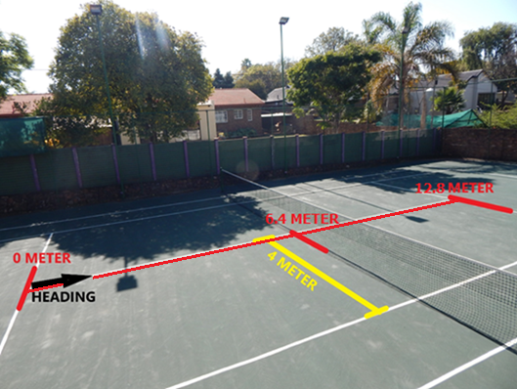

Fig. 15 Relevant dimensions of the tennis court for the purpose of the experiment

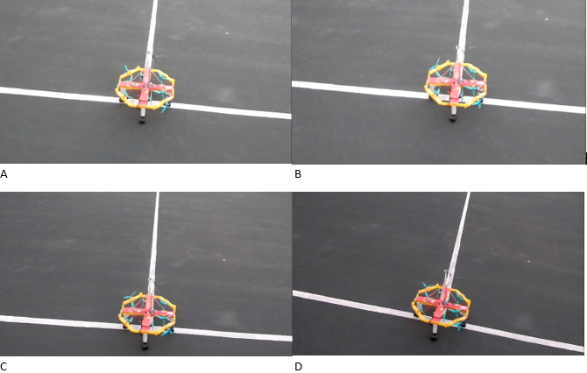

Fig. 16 A to D – The droverbot was setup so that the 0° or 360° (heading orientation) is the white line in front (towards the net) of the droverbot.

## Correlation of Video Footage and Data Logger Results

For each of the four repeats of the experiment, the orientation data logged were combined and manually synchronized with the video footage to reflect all the completed 360° turns of the droverbot.

# Results and Analysis

The results are presented below in figures, a table and other visual aids to support the analysis.

## Video Footage Analysis

The analysis of the video footage captured during the experimental setup provides valuable insights into the operation of the novel propulsion system of the droverbot. Four repeats were recorded. The video footage analysis aimed to evaluate if forward propulsion occurred during different repeats of the experiment.

### Forward Propulsion Assessment

The video footage was examined to determine the droverbot’s ability to travel along a steady travel path during various repeats of the experiment. Although deviations from the desired trajectory (Heading direction, see Fig. 15) were observed, forward propulsion did occur. See Fig. 17 A to D

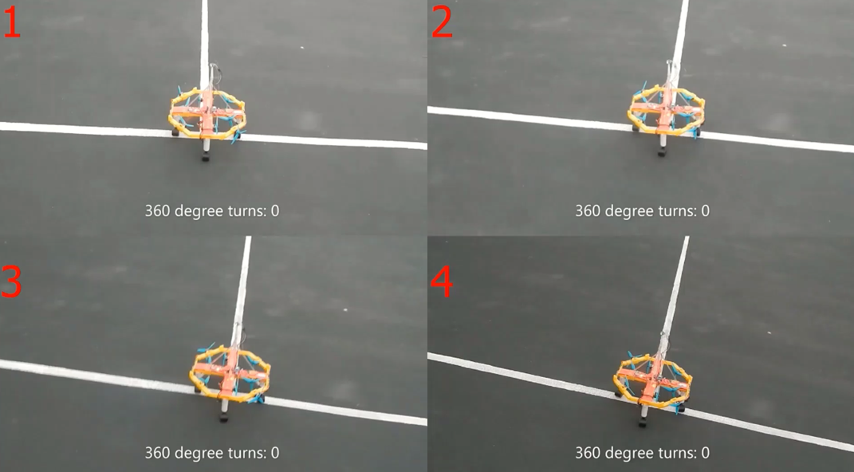

Fig. 17 A Starting position - 360 degree turns: 0

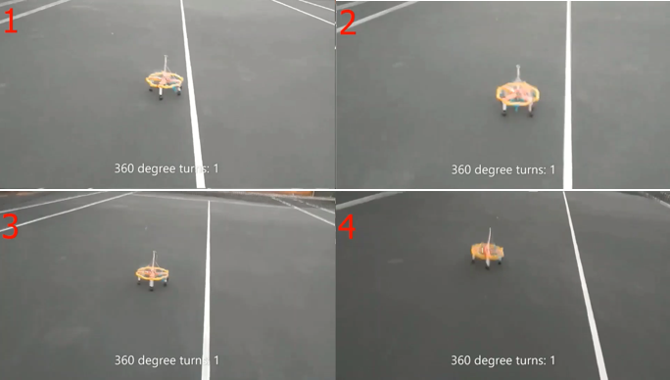

Fig. 17 B 360 degree turns: 1

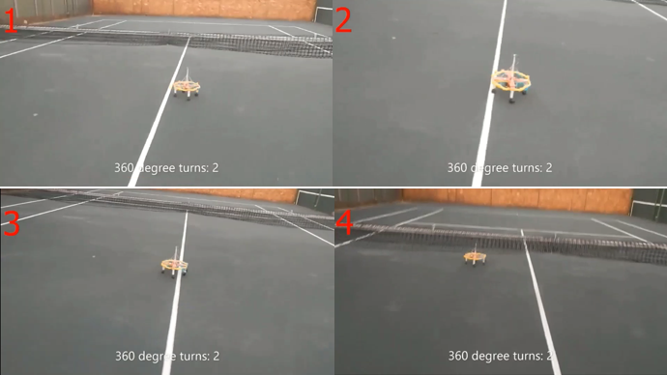

Fig. 17 C 360 degree turns: 2

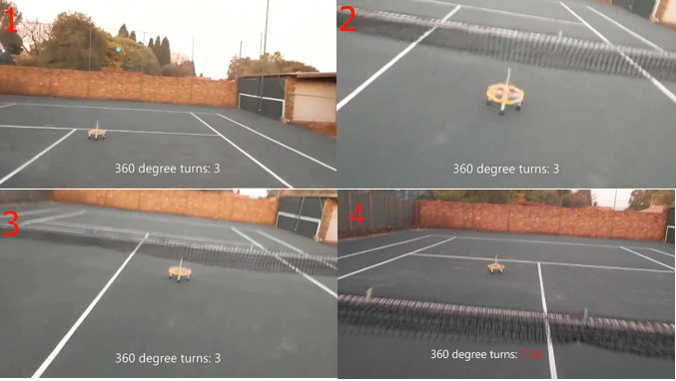

Fig. 17 D 360 degree turns: 3

The heading direction is the white line in the middle of the court and deviations from this line were observed as follows: Repeat 2 deviated the most and Repeat 1 the least. Repeat 4 did not deviate much more than repeat 1. Repeat 3 and repeat 4 deviates almost the same. Repeat 2, which deviated the most, still propelled forward.

Repeat 1 and repeat 4 covered the longest distance, followed by repeat 3 and repeat 2 covered the shortest distance. All repeats finished on the righthand-side of the white-line, except repeat 4

## Data Logger Measurements

The analysis of the sensor data recorded during the experimental setup provided valuable insights into the operation of the novel propulsion system of the droverbot. The data analysis aimed to evaluate orientation data, specifically heading, as the droverbot propelled horizontal on the surface of the tennis court.

### Sensor Readings

Each iteration recorded 82 readings in just over 5 seconds for each repeat. An average of 16 reads per second were obtained. Table 1 below shows that all repeats completed three 360° turns in just over 5 seconds, except repeat 4, which only complete 2.58 turns (See Table 1 - Partial completion of 360°). Repeat 2 rotated the most, followed by repeat 3, then repeat 1 with repeat 4 rotating the least. For a more detailed view of the turns, the last two columns of Table 1, turns are depicted in 120° segments completed as well as the percentage of the last segment that did not complete.

|  |  |  |  |  |  |  |  |
| --- | --- | --- | --- | --- | --- | --- | --- |
| Table 1 Data logged | | | | | | | |
|  | Total Sensor Readings | Duration (Seconds) | Completed 360° Turns | Partial 360° Turns  (% completed) | Completed 120° Segments | Partial 120°Segments (% Completed) | |
| Repeat |
| 1 | 82 | 5.2 | 3 | 7 | 9 | | 22 |
| 2 | 82 | 5.2 | 3 | 82 | 11 | | 48 |
| 3 | 82 | 5.2 | 3 | 64 | 10 | | 9 |
| 4 | 82 | 5.2 | 2 | 58 | 7 | | 75 |

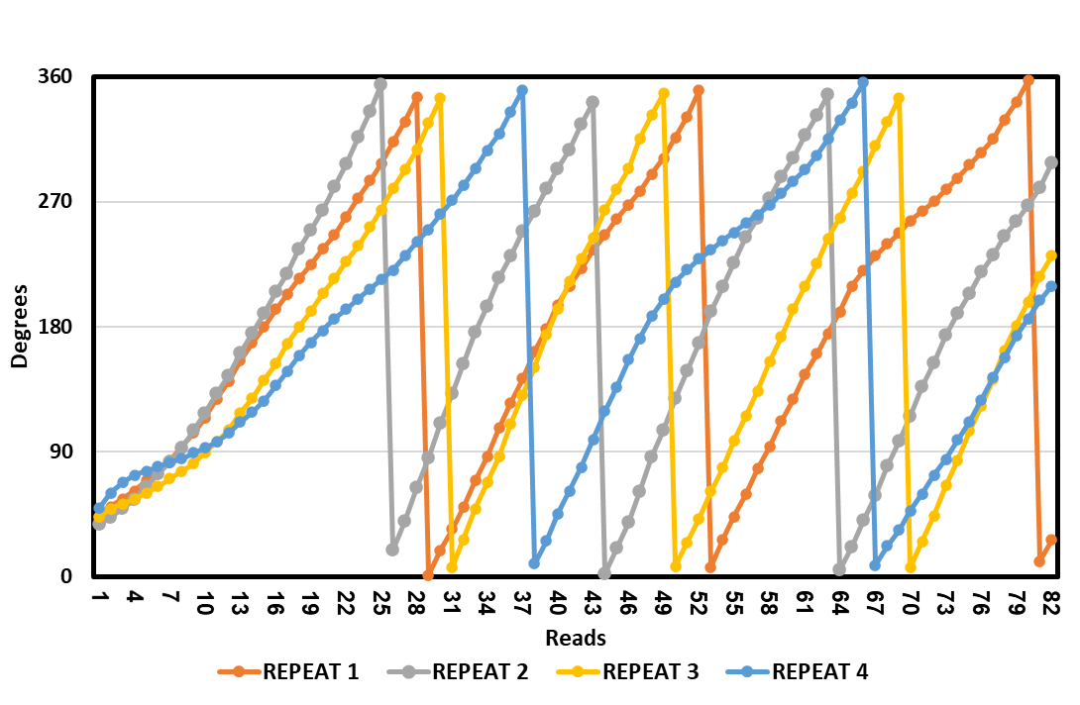

Fig. 18 Turns – Reads per repeat

From the Fig. 18 above, the following results can be derived:

1. With the first 360° turn completed by all repeats, the following observations can be made:

Repeat 2 completed the first 360° turn after 26 reads. Repeat 4 was the slowest after 38 reads. Repeat 1 and 3 are similar with only 2 reads apart for their first turn completed with Repeat 1 at 29 and Repeat 3 at 31 reads.

1. With the second 360° turn completed by all repeats, the following observations can be made:

Repeat 2 again completed its turn first after 44 reads. Repeat 3 and 1 are similar again but repeat 3 completed its turn now before repeat 1 at 50 reads. Repeat 1 completed its second turn at 53 reads. Repeat 4 again is the slowest and only completed its turn at 67 reads. All the second turns completed in less reads than the first turns did.

1. With the third 360° turn completed by most of the repeats, the following observations can be made:

Repeat 2 again completed its turn first at 64 reads, followed by repeat 3 at 70 reads. Repeat 1 only completed its turn at read 80. Repeat 4 did not complete a third turn and was only able to make 180 °turn at read 80. Repeat 1, repeat 2 and repeat 3 completed their third turn in more reads than their second turn.

1. No more than three turns were made by any repeats, however repeat 2 made another 270° turn and repeat 3 a 180° turn before reaching their 82 reads.

## Motion Performance

The primary objective of this study is to evaluate if forward propulsion occurred. However, since the dimensions of a tennis court is well known, a qualitative calculation of the speed and acceleration of the droverbot were conducted. Repeat 1 was chosen as the basis for this calculation as it almost cross the opposite service line of the tennis court while the thrusters were active. The distance between the service lines is 12.8 meter (based on tennis court dimensions), and since the droverbot almost passed the opposite service line of the tennis court, 12 meters was accepted to be the distance travelled. (12 meters was deemed the distance travelled with the thrusters actively running.)

Distance droverbot travelled: 12.0 meters

Duration: 5.2 seconds

Speed:

v=d/t

v= 12.0/5.2

v=2.30m/s

Acceleration:

a=(Vf-Vi)/t

a = (2.30-0)/5.2

a = 0.44 m/s2

As said above in the V. Experimental Setup under B. Limitations, all the thrusters were configured at 70% of their total RPM capacity. This was done to ensure that the droverbot does not collide with the fence of the tennis court and damage the droverbot. Also, having the droverbot at a lower speed improve observations regarding forward propulsion, which support the main objective of this study. At 100% RPM the thrusters are capable to deliver double the thrust compared to 70%.

Overall, the analysis of the video footage shown that forward propulsion has been obtained with all repeats, and that with some repeats the droverbot travelled longer distances than other. The analysis of the data of the integrated data logger of the droverbot, shows that the data recorded as per 360° turns. A comparison was presented between all the turns of all the repeats. Finally, a qualitative measurement of the speed and acceleration of the droverbot was conducted for the repeat that have travelled the longest distance.

# Discussion

## Interpretation of findings

The findings from the data logger, together with the video footage analysis supports the research objectives of this study, which aimed to develop and evaluate the droverbot prototype with a novel propulsion system. The results show that the droverbot with a novel propulsion system does rotate, in its entirety, while propelling forward.

Deviations, for all repeats, from the heading direction were observe but not substantial enough to invalidate the forward propulsion that occurred. Several reasons could contribute to the deviations, for instance:

The tennis court features minor bumps occasionally. The omni-wheels does not have any shock absorbers and therefore they are more sensitive to the hard surface they roll on. This could impact the movement of the droverbot.

The Adafruit BNO055 component have a heading accuracy of 2 degrees in an ideal environment.

Additional “program code” could be written to refine the guidance system.

Based on the above observation that forward propulsion occurred, the ejected fluid had to be curved. That is an inherent consequence of the droverbot that rotate while it propels forward. Given that the droverbot propels forward while curving ejected fluid illustrate a unique important property of the droverbot.

## Analysis of Findings

In the analysis of the findings, the data collected were carefully examined to uncover key patterns and correlations with the aim to provide valuable insights into the implications and potential applications of the droverbot.

### Discussion of the 360° turns of all the repeats

### 1st and 2nd turn

All 2nd 360° turns of the repeats were faster than the 1st 360° turns of the repeats as it took less reads to complete the 2nd turn than the 1st turn. This is acceptable since the droverbot starts from a position of rest, which is not the case with the 2nd turn. This is also an indication that the opposing set of thrusters (See Fig. 11 B) did not decrease the rotational motion speed with the 2nd turn compared to the 1st turn, since the required rotational motion speed, as governed by the guidance system, have not been obtained after the 1st turn.

### 3rd turn

The repeats that completed their 3rd 360° turns (Repeat 1,2 and 3), did turn slower than their 2nd 360° turns as it took more reads to complete the 3rd turn than the 2nd turn. This is also an indication that the opposing set of thrusters (See Fig.11 B) indeed did create a lever to slow down the rotational motion speed, since the set of thrusters that generated more thrust in the 2nd 360° turn, was now generating less thrust with the other set generating now the most thrust. (The functionality of the lever is a build-in feature of the guidance system)

### Discussion of the correlations between distance travelled and 360° turns

Repeat 2 made the fastest 360° turn of all the repeats, deviated most from the heading direction and also travelled the shortest distance of all the repeats.

Repeat 1 and Repeat 4 made the slowest 360° turns of all the repeats, deviated the least from the heading direction and also travelled the longest distance of all the repeats.

From the above it could be concluded that how faster the rotation is, the more deviation from heading will occur as well as less distance cover. In the early stages of the developing the guidance system, uncontrolled accelerating rotational motion caused the droverbot to deviate almost 90° from the heading direction, however, with the introduction of an opposing set of thrusters (See Fig.11 B), a lever has been created to facilitate a controlled rotational speed. That said, faster turns do not necessarily imply that heading cannot be maintained, even over longer distances. With the experiment conducted with the droverbot, it might be a case of design and “program code” improvements that are needed as well as the need for higher quality electronic components. For example, the Adafruit BNO055 is a fairly inexpensive IMU component and if replace with a component with better specifications, the results could very likely be positively different.

### Insight: Forward propulsion in any direction on any one of the three axes

The droverbot, as a standalone unit, can forward propel along the horizontal plane in any direction. This implies that the droverbot are capable in propelling on the X and Y axes, however, to do so on the Z axis, a single unit droverbot needs to be orientated vertical. (Horizontal forward propulsion was chosen for this study as indicated above III. Methodology – A. Conceptual Design)

To be able to propel along the horizontal plane in any direction, more than one method exists on how this can be done:

### By adjusting the heading direction programmatically to any degree between 0° and 360°

With the droverbot prototype, the Adafruit BNO055 sensor is orientated parallel to the horizontal plane. By physically rotating the sensor, heading can be determined for forward propulsion. Once the sensor has been rotated and calibrated, its orientation before any movement will be 0°. (All repeats of the experiment above started at 0°).

### By programmatically pair different thrusters, the heading direction can be changed

As described in a. above, once 0° have been determined, heading direction can also be implemented by combining different sets of thrusters as illustrated below. In practice, an offset of degrees from 0° will be used as heading (resultant force) depending on which thrusters sets are being used.

Fig. 19 below illustrate the possibilities of heading (resultant forces) in different directions when different combinations of thrusters are paired.

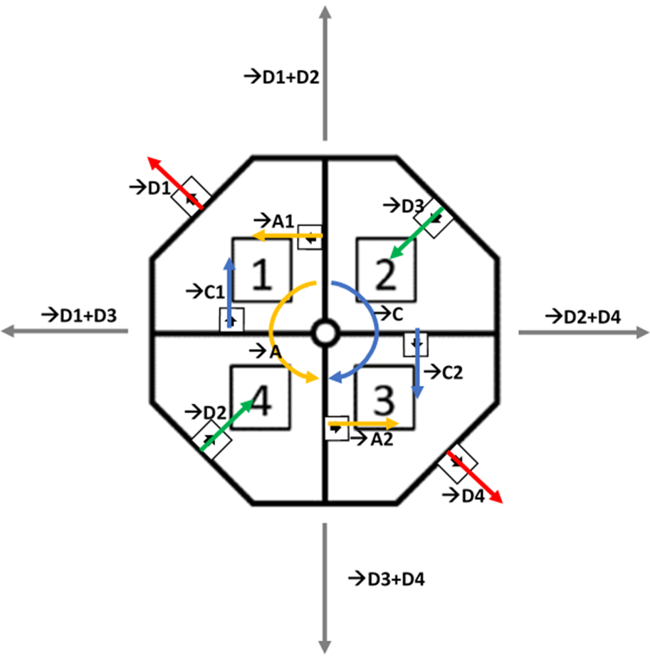

Fig. 19 Resultant forces possible with different pairs of thrusters combined

### Insight: Forward propulsion along any or any combination of the three axes with a droverbot-based craft

The droverbot, as a standalone unit, can only move along two of the three axes, in any direction, but by adding droverbots together to a common frame, orientated on each axis to enable roll, pitch and yaw, the droverbot-based craft can forward propel on any of the three axes or in any combination of the three axes. This is possible, because just like wheels, it can be added to the body of a car through axles, each droverbot have a hub for an axle to be inserted (See Fig. 9 as pointed by A). Since a droverbot is in an octagon shape, an axle will be fitted into a hub at the centroid of the octagon. Axles are part of the common frame. With axles orientated in such a way that they represent all three axes, the droverbot-based craft will be able to propel in 3D space in any direction. By being able to add units together, the droverbot-based craft is also able to scale, that is, the limitation of how many units can be added are limited by the common frame design. See Fig. 20 below for an example of how such a vehicle can be constructed. (This is just an illustration of what kind of craft might be possible and not necessarily a viable or practical craft)

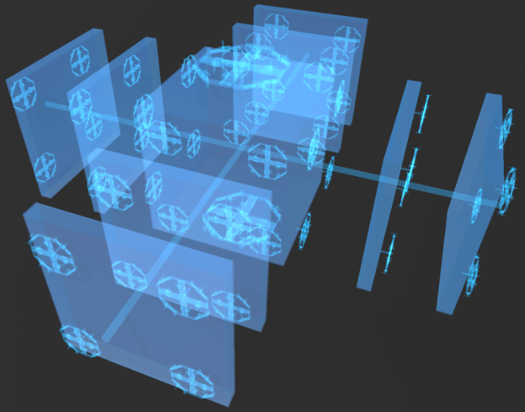

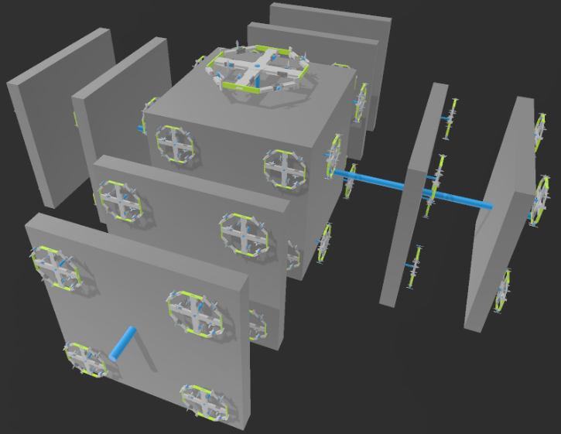

Fig. 20 The blue rods connect multiple layers with droverbot units - on all three planes - together to a common frame to form a droverbot-based craft.

### Qualitative experiment: Visually confirm the curving of air ejected by the propeller.

As stated above in “VII. Discussion - A. Interpretation of findings”, that fluid is curved when the droverbot propels forward while rotating, the curving of the fluid cannot visually observe. To physically show how the ejected fluid is being curved, a qualitative experiment was conducted and is described below.

**Methodology**

An artifact as shown below was constructed.

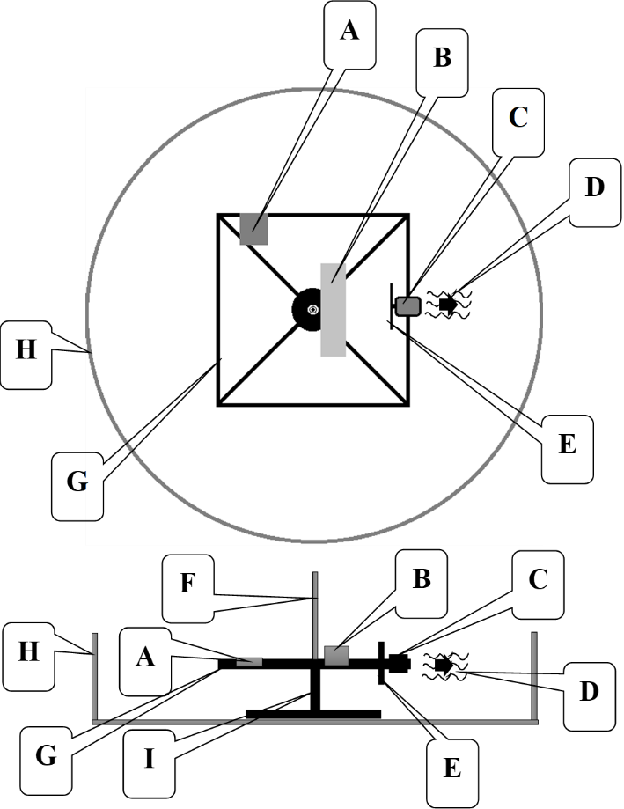

Fig. 21 Artifact to illustrate visually the curved flow of ejected air from a thruster while the thruster is rotating.

1. **4.5 V Battery pack**

The battery pack supply power to the DC motor

1. **Dry-ice pieces in a container**

Several pieces of dry ice were placed in a container

1. **DC Motor**

DC Motor, attached to the frame (**G**) was placed so that an attached propeller (**E**) will face the dry ice

1. **Ejected dry ice vapour**

Ejected dry-ice vapour via the motor propeller.

1. **Model#:R38-BL-PC HeadsUp Racing Prop R38 (2CW+2CCW)-Poly Carbonate**

Propeller attached to the DC Motor (**C**)

1. **Shaft**

Shaft with a length of 20 cm attached to the frame (**G**).

1. **Frame**

The frame is attached to a stand (**I**) via a bearing.

1. **Plastic container**

The plastic container is used to limit the influence of the surrounding airflow.

1. **Stand**

The stand is located in the middle of the container and hosting the frame, which can rotate via a bearing.

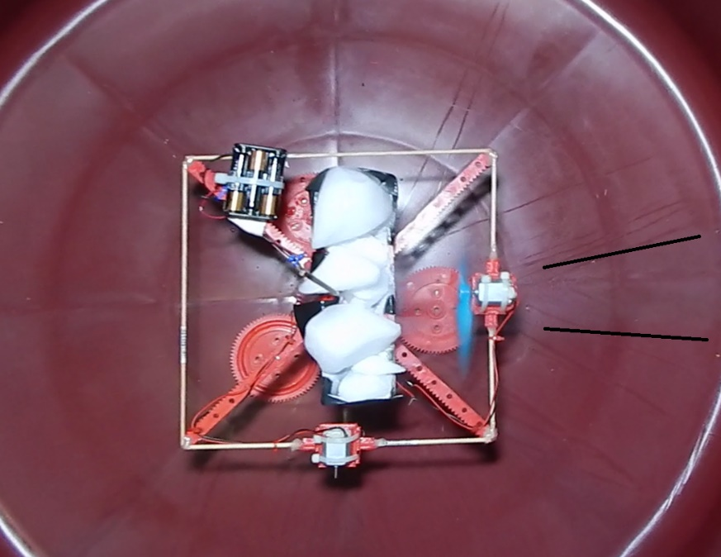

Fig. 22 Components of device (add basin description; Change fonts)

**Experimental Setup**

The artifact was put in a large circular plastic container and a room where ventilation was restricted during the experiment. Dry ice was put in-front of a thruster (propeller with motor).

which then eject the dry ice vapor. Fig. 22 shows the device stationary (the device is not rotating), with the thruster spinning. The fluid being ejected is in a straight line behind the propeller.

The shaft is then hand propelled, anti-clockwise, while the thruster’s propeller is spinning to show how the fluid curve behind the propeller and the effect of that can be observed in Fig. 23 and Fig. 24 below.

**Limitations**

The view of how fluid is curved while the device is being rotated are limited by the amount of dry ice place on the device. Spinning the device by hand only allow the device to reach a low RPM.

**Results**

In Fig. 23 and Fig. 24 below, it can be observed that the dry ice has been curved when ejected by the propeller. See the arrows pointing to the area where the fluid is being ejected

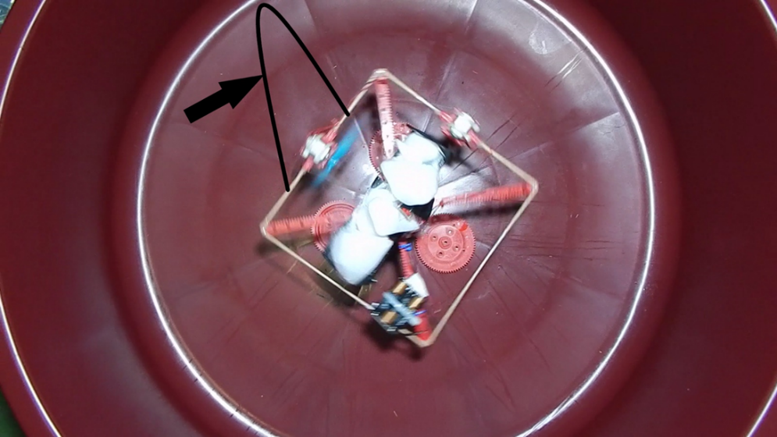

Fig. 23 The arrow point to a black line around the ejected dry ice fluid

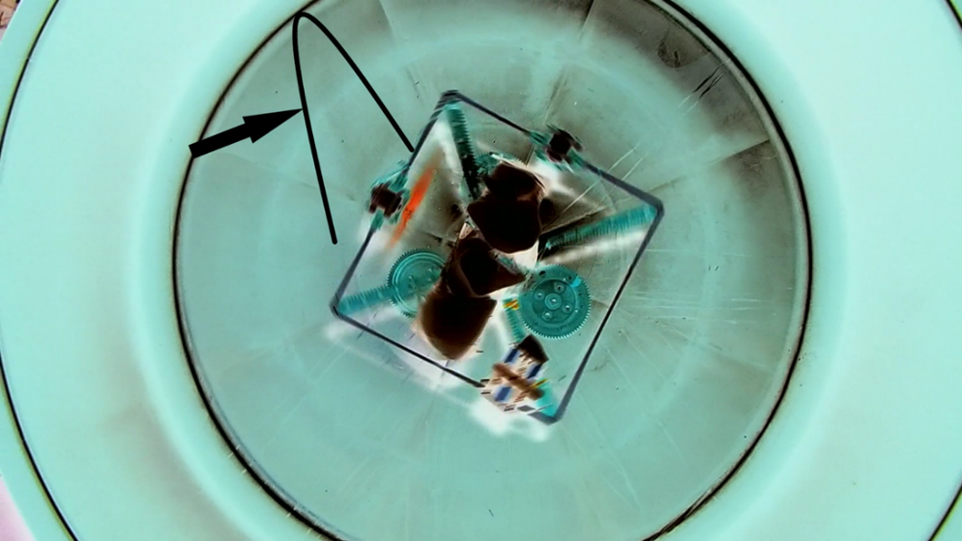

Fig. 24 Showing the above image in negative colors.

**Discussion**

An observation was made when there is no rotation, the fluid is ejected in a straight-line as shown in Fig. 22. When the device is being rotated via the shaft, the fluid starts to curve as seen in Fig. 23 and Fig. 24. It was also observed that the faster the device rotates, the more the fluid is being curved.

### Insight: Curving of fluid – thrusters on octagon frame and thrusters on rods.

Thrusters on the octagon frame produce forward propulsion (linear motion) and thrusters on the rods produce rotational motion. Below follows a detailed discussion of each.

### Thrusters located on the octagon frame

Instead of ejecting fluid like rockets (or airplanes) whereby the re-action force causes the rocket (or airplane) to propel forward with a straight angle to the ejected fluid (action force) (See Fig. 25 B), the ejected fluid will displayed as being curved at an obtuse angle in the opposite direction of the rotational motion of the droverbot, continuously (See Fig. 25 A1 and A2 - G). Even thou the fluid is at an obtuse angle after leaving the blades of a thruster propeller, forward propulsion is still obtained by vector addition of a pair of thrusters that works together while the droverbot rotates in its entirety. (See Fig. 25 🡪D1+D2; Also see Fig. 14 above on how a pair of thrusters on the octagon frame works together). The fluid is ejected in a straight angle behind the propeller but due to the rotation of the thrusters on the octagon frame, after a few milli seconds, the fluid is being ejected at a different position. Therefore, the fluid ejected is not reinforced by more fluid to reach further at a straight angle behind the propeller. The ejected fluid will also collide with fluid that is largely at rest (See Fig. 25 C) as the droverbot rotates continuously. This also implies that ejected fluid is being offset against rotational thrust on a continuous basis (See Fig. 25 🡪C1+C2). In other words, the action force of the ejected fluid is being offset against the rotational thrust of the droverbot (re-action force). The thruster (See Fig. 25 E) does not spend enough time at a position to cause a very deep disturbance of the fluid at a straight angle. This also implies that fluid will still be largely at rest a distance away (See Fig. 25 F). When comparing to fluid ejection of a rocket, the fluid from the rocket is ejected in a straight angle continuously. This implies that the fluid does cause a deep disturbance of the fluid at a straight angle behind the rocket (See Fig. 25 B).

Fig. 25 A1 and A2 below depicts how the ejected fluid is curved outward by the inner thrusters (See Fig. 25 E) as well as the intake of fluid by the outer thrusters (See Fig. 25 H). Both are located on the octagon frame while the droverbot (Fig. 25 D) is rotating.

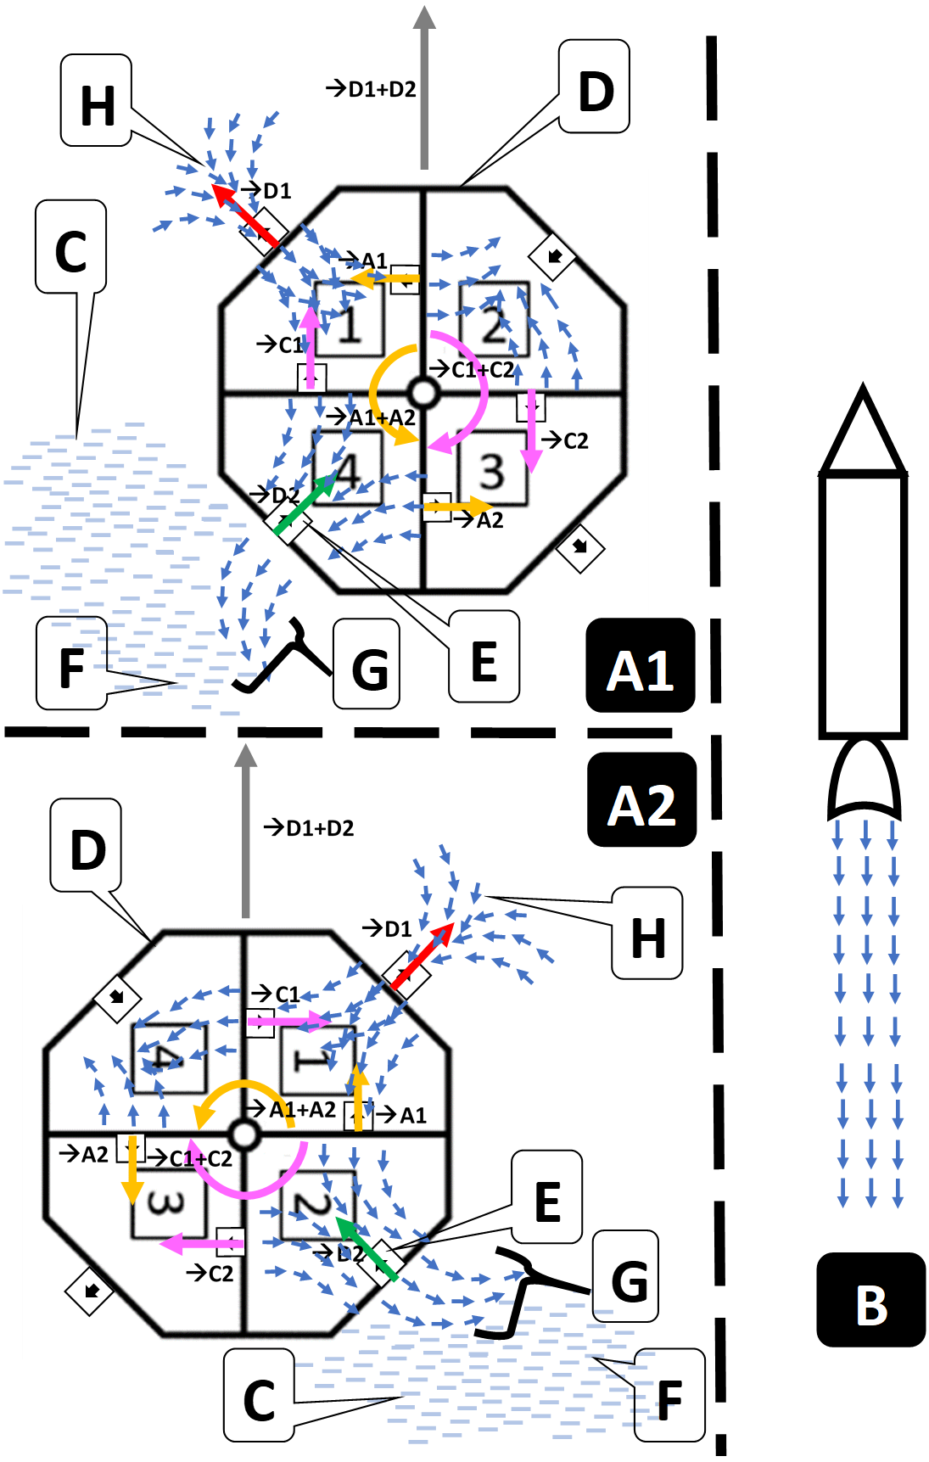

Fig. 25 A single position in time of (A1 and A2) fluid being curved at obtuse angles and (B) fluid being ejected in a straight-line at a straight angle to the rocket.

### Thrusters located on the rods

As presented above (IV. Propulsion System - A. Rotational Motion), a pair of thrusters, essentially forming a force couple, on one of the rod’s makes the droverbot rotates clockwise (See Fig. 25 🡪C1+C2) and the other pair, on the other rod, makes the droverbot rotates anti-clockwise (See Fig. 25 🡪A1+A2). This creates a lever, which allow the droverbot rotation to be speed up or slowdown. As with the thrusters on the octagon frame, these thruster pairs on the rods are continuously rotating, therefor the fluid ejected is also curved. However, given their continuous use and different mounting orientation compared to each other and the thrusters on the octagon frame, complex streams of fluid streams can be expected. In Quadrants 1 to 4, in both A1 and A2 of Fig. 25 a predicted flow of fluid is depicted.

### Comparison: Droverbot technology versus existing drone technology as well as other fluid processing vehicles

As stated above in - II. Literature Review - rotorcraft like quadcopters are preferred for tasks that require hovering and maneuvering in tight spaces, such as inspection and surveillance of buildings and infrastructure. In contrast, fixed-wing drones are suitable for longer-range flights and mapping applications that require high-speed and long-endurance flights. This study only introduces the droverbot and its unique method of propulsion. With a complete implementation of the droverbot technology as discussed in this study, its full potential will be realised. However, the key abilities of the droverbot will be briefly highlighted that are unique compared to existing drone technology and other fluid processing vehicles.

A droverbot-based craft can have a flexible design as describe above in *4.Insight: Forward propulsion along any or any combination of the three axes with a droverbot-based craft*. Fixed-wing drones have a fairly fixed shape comparable to an airplane. Rotorcraft have more flexible designs and can be attached to external bodies. As seen in Fig. 20, a droverbot should be able to scale in units on any or all axes and processing fluid on all three axes to produce thrust. Currently, mainstream propulsion vehicles (airplanes, drones, boats etc.) that forward propel and process fluid (air; water) will eject fluid largely in a straight line continuously after it left the propeller blades of these vehicles. The ejected fluid is continuously at a straight angle to the thrusters of these vehicles. In contrast, the droverbot thrusters will eject fluid not in a straight line continuously after it left the propeller blades, but the fluid will be curved.

With airplanes and fixed-wing drones, propellers are mounted on the horizontal plane and with helicopters and rotorcraft like quadcopters it is mounted on the vertical plane. In contrast, droverbot thrusters are mounted on the horizontal and vertical planes.

Since the droverbot curves eject fluid due to rotation, the ejected fluid is distributed. This could potentially lead to an enclosure of droverbot units, which could have many other implications and will be discussed below.

## Implications for Future Development

The droverbot introduces the capability of forward propulsion while the whole vehicle is rotating. While it produces forward propulsion, the way fluid is ejected from its thrusters, is different when compared to other mainstream propulsion vehicles. Furthermore, the droverbot should be able to scale on two levels, size and quantity. Firstly, the prototype used in this study should be able to scale (larger octagon frame, thruster motors and propellers), as this propulsion technologies it uses are well known in the aviation industry. Secondly, since an axle can be fitted to the droverbot center, many droverbots can be added to a common frame. Said differently, the droverbot units can scale in quantity. A common frame design for multiple droverbot units, unlike airplanes and boats, can be far more flexible in size and shape. As long as droverbots can be added on all three axes, center of gravity on the common frame can be determined and a central computer can manage flight stability and pilot input. See Fig. 20 above and let’s envision this square box in the center is 100 meters by 100 meters. This could be a heavy cargo aircraft that is not possible with current technology. The common frame design will dictate the scalability in size and quantity of the droverbots attached to it. Because craft like this can be possible, there could be a new branch of fluid processing propulsion craft in the future.

Another key potential capability of the droverbot could be: “What happens when the droverbot is capable to retain all the fluid it processes to propel?” How can the fluid be retained? Since the ejected fluid is not at a straight angle to the thrusters and the thrusters are always in rotational motion, these unique attributes have the potential to allow the droverbot to be enclosed. An enclosure could be fitted via the hub and axle at the center of the droverbot. Such a vehicle will be able to retain its propellant, never run out of propellant. This however do imply that the energy source is not store in the propellant, but separate. This also indicate that the droverbot-based vehicles will not be limited to just on earth and on water, in the atmosphere and under water, but will also be able to access the vacuum of space. Space will be made accessible in a way that was never possible before by not needing rockets, but by adapting current aviation propulsion technology. Such a vehicle will be the ultimate in re-usability, since it won’t discard even its propellant. Said differently, air molecules as a scarce resource in the vacuum of space. They should not just be used once and ejected, but retained and re-used.

Below follow two key detail points, discussing how the retainment of propellant is possible by enclosing a droverbot type of vehicle and still be compliant with Newton’s 3rd law of motion.

1. Newton’s 3rd law represents the ejection of fluid from any propeller as follows: The action force happens when the fluid is ejected by spinning propeller blades. The reaction force is on the propeller blades when ejecting fluid and that result in moving the propeller blades (and everything attached to it) in the opposite direction of the ejected fluid. The total fluid ejected – action force - equals the total effect on the propeller blades - re-action force.

Let’s now elaborate on a droverbot fitted with an enclosure in regard to fluid ejection, in the context of Newton’s 3rd law. In the case of rockets (and other mainstream propulsion vehicles like airplanes and boats), the ejected fluid are largely ejected in a continuous opposite force in line with re-action force. In cases like these, if say, an enclosure is put around a rocket, mounted to the rocket, the rocket will not move at all. Why? Because the fluid ejected from the rocket is in a straight angle with the re-action force that propel the rocket forward, therefore the fluid will bounce against the wall of the enclosure, which are mounted to the rocket. This will render a net force of zero. (See Fig. 26 B below). Similarly, this will also be the case with airplanes and boats if they were to be surrounded with an enclosure.

However, with the droverbot, the fluid is curved because of continuous rotation of the droverbot in its entirety. The fluid's expelled range – in line with the re-action force - is less because it’s not continuously re-enforced by more fluid expelled from the propeller blades, but only for a fraction of a second, before the octagon frame-based thrusters rotate to a different position (See Fig. 26 G – Curved fluid). This causes the fluid to reflect as being curved continuously as appose to being a continuous opposite force, that is in line with the re-action force on the droverbot as in the case with rockets, boats and airplanes.

1. Can the ejected fluid from the octagon frame mounted thrusters be offset against rotational thrust? Since the fluid ejected by the octagon-based thrusters’ curves, which is a result of the rotation and the collision with fluid mostly at rest as the drone rotates (See Fig. 26 C – Fluid at rest). This can be compared to extending your hand out of a moving car and feeling the air collide with your hand. The expelled air (of the droverbot) is taking the place of a hand extended out of the moving car window. Because of these collisions, it could then be said that ejected fluid is offset in a meaningful way against rotational thrust generated by the thrusters mounted on the rods.

Because the ejected fluid is curved and offset against rotational thrust, it should be possible to enclose the droverbot without the zero net force effect that apply to propulsion systems that eject fluid in a straight-line like rockets, airplanes, boats and current mainstream drones. Fig. 26 A and B depicts Fig. 25 A1 and B but with an enclosure. Fig. 26 I indicate the enclosure and J (see the sideview) the axle that connects the droverbot with the enclosure.

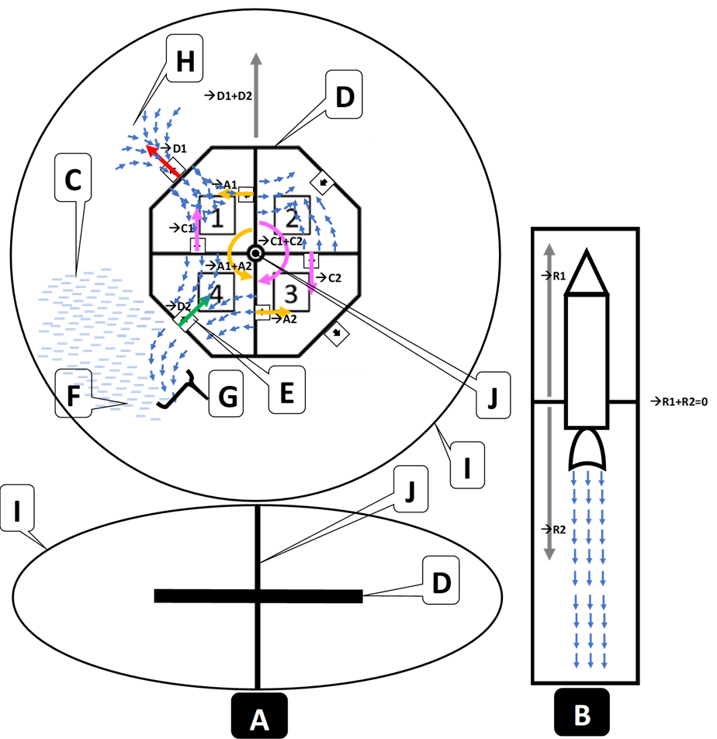

Fig. 26 A single position in time of an enclosed drone and enclosed rocket

# Applications of droverbot technology

Future applications of the droverbot technology could potentially have significant impact on transportation in several environments. Three key unique properties of the droverbot technology establish a platform from which novel applications can be created. The three key unique properties are as follows:

The ability to mount droverbot units at scale to a common frame in a far more flexible manner (See Fig. 20 as an example) than what current vehicles that process fluid to propel forward, offers.

Droverbot units can be mounted and scale on all three axes.

The potential to enclose droverbot-based vehicles completely because its thrusters eject fluid at an optuse angles, and not at a straight angle like current propulsion vehicles that process fluid to propel forward.

Droverbot-based vehicles can be divided into two main areas, applications without enclosure and applications with enclosure.

## Applications without enclosure

Droverbot-based vehicles without an enclosure can function uniquely and similarly to current vehicles that process fluid to propel forward. Droverbot-based vehicles may have advantages and disadvantages when compared to them. Below are some novel applications for droverbot-based vehicles without an enclosure.

Droverbot-based vehicles can build at scale for air freight and not be limited to current airplane freight bays sizes. (Fig. 20 is an example of such a vehicle that are able to scale in size and thrusters)

Droverbot-based vehicles can scale to a size to construct floating platforms (or cities) in the sky.

Novel types of ships on the oceans, using modified versions of droverbot units with propellers optimized for water.

## Applications with enclosure

The potential to fit enclosures around droverbots will enable them of retaining propellant. When propellant is retained, only energy can be depleted, not propellant, since the propellant is recycled in the enclosure (such propellant is named, Encropellant). Encropellant can be a cold gas like oxygen and/or potentially other gases (or a mix of them), which will not be able to escape the enclosure. Below are some applications with a droverbot-based vehicle that is surrounded by an enclosure:

Propellant as a percentage of total vehicle mass - With a droverbot that is enclosed, propellant can be recycled, and therefore, less propellant is needed since the propellant is not lost after one use. The implication is that smaller droverbot-based vehicles can carry much more cargo as a total percentage of the total mass of the vehicle.

Droverbot-based vehicles that can operate in several mediums, that is, on earth and sea, in the atmosphere or under water as well as in outer space. The effect of the medium on the vehicle’s propulsion system are restricted to the outside surface area of the vehicle’s enclosure.

Continuous propulsion - If a vehicle, like a spacecraft’s propellant is recycled and never lost, coupled with an energy source that can last over a decade or more, such a spacecraft can travel to far off places in the solar system (and even beyond) in record time due to continuous acceleration.

Spacecraft capable of continuous propulsion can eliminate the effect of micro-gravity on the human body.

Since the propulsion system is enclosed, thruster unit noise will be dampened which limit the spread of noise pollution.

An enclosed droverbot-based vehicle can be designed to be an aerodynamic shaped craft that can be potentially superior to any existing craft in that regard. This could potentially result in vehicles with low levels of drag when flying in the atmosphere. Secondly, most or all vehicle parts will be enclosed, therefor lose parts falling from the sky could be limited.

By enclosing a vehicle, the transition from a different medium to another, say from space to air, and air into water, most likely won’t require significant additional technology.

Droverbot-based vehicles can be built with today’s propulsion technology that exists in the aviation and space industries.

Satellites in orbit are merely a convenience due to not enough fuel to keep them up there. That can be replaced with satellites that can be positioned and moved at will. How? Since propellant is recycled and solar energy are available, satellites have the potential to never run out of fuel.

Transportation vehicles on earth (or other planets/moons) will have the capability to float, wheels will be optional. Droverbot-enabled objects (like shipping containers) on the surface will have the ability to float.

Since droverbot-based vehicles are enclosed, weather conditions should not affect a vehicle to lift-off in difficult weather conditions when comparing to rockets and aircrafts. The effect of the weather is restricted to the outside surface of the enclosure, and the vehicle’s maneuverability can be adjusted as needed via thrusters on all three axes.

Droverbot-based vehicles can scale to a size to construct floating platforms (or cities) in the sky. When thrusters are enclosed, such platforms will have less noise pollution, less interference from upper atmospheric winds as well as no parts falling from the sky.

Spacecraft re-entry into any atmosphere can be controlled at a chosen speed. Exiting into space does not need to put a vehicle into orbit first, it can just leave.

Various kinds of shaped craft are possible. As long as the workings of the propulsion system is not affected, craft with enclosures in the shape of triangles, cylinders, squares or rectangles or other shapes can be constructed. See Fig. 27 below:

## 

## Fig. 27 The yellow, orange and green droverbots can cause propulsion and rotation in any or any combination of the three axes.

Since the droverbot has a centroid (octagon-shaped frame), the resultant force can be changed to any angle from 0 to 360 degrees on all or any of the three axes (See VII.Discussion - B. Analysis of Findings 4). With that ability, droverbot-based vehicles will be capable in reversing propulsion which will result in slowing down from high speeds in space and on earth. Droverbot-based vehicles can also make orientation changes in small increments that can go unnoticed for passengers travelling in outer space, therefore making a curved path to keep gravity intact for passengers and cargo is an elegant way of transitioning between acceleration and de-acceleration halfway to the destination. See Fig. 28 below as an example of such a path. At A, the vehicle is accelerating towards C. However, by making small adjustments in orientation, the acceleration is curved slightly upwards. (Also, remember the speed this vehicle is at currently at its highest and need now to be deaccelerated in preparation for landing at the destination.) At B, the orientation changes will stop and will automatically slow down the vehicle be accelerating against the current speed the vehicle is travelling at. The destination will now not be at C, but at D. This however can be adjusted over the course of the de-acceleration of the vehicle. This is called the InvertoSpin.

## 

## Fig. 28 A depiction of InvertoSpin.

The alternative to InvertoSpin would be to flip the craft 180° and reverse the drone’s rotation, but any humans and lose items in the craft will not re-act good to that.

# Conclusion

In conclusion, this manuscript introduced a groundbreaking and novel propulsion technology that holds significant promise for various applications in the field of propulsion. Through many years of rigorous experimentation and analysis, I have now introduced a novel propulsion system by demonstrating it with the droverbot. The potential of this propulsion technology can address critical challenges and opening new avenues for advancement.

The interpretation of my findings reveals that this novel propulsion technology offers unprecedented capabilities, by deriving forward propulsion from a vehicle that is rotating in its entirety, and in doing so, also curving ejected fluid, which is largely offset against the rotational thrust. The analysis of the data confirms the validity of the propulsion technology, showcasing its ability to repeatedly propel forward. These findings also inspire further research and development of this novel propulsion technology.

The implications for the future are potentially vast and exciting. The introduction of this propulsion technology has the potential to transform the transport sector and all sectors that depend on it. With its ability to enable novel applications, this propulsion technology opens up new possibilities for innovation and progress. The integration of this propulsion technology into existing propulsion technologies has the potential to revolutionize industries and bring about significant positive change.

Moreover, the application of this propulsion technology holds immense promise. By harnessing its capabilities, we can envision advancements in transportation on land and oceans, in the atmosphere and under water, as well as outer space.

In conclusion, the findings presented in this manuscript provide a solid foundation for future research, development, and practical implementation. With its potential to transform industries and improve the quality of life, this technology paves the way for a brighter and more technologically advanced future.

## Future research directions

Future research directions for the droverbot could include further improvements to the design and integration of additional sensors. This would enable more advanced and sophisticated applications (See section VIII. Applications of droverbot technology). Key areas of research suggested are as follows:

1. Droverbot need to accelerate more than 9.81 m/s2. Experimentation with scaling a droverbot unit while considering total mass and thruster’ capability, more than 1G acceleration could easily be accomplished. Even the current droverbot used in this example are much more capable as discussed earlier (See VI.Results and Analysis - C.Motion Performance ).
2. Use of industrial graded components. To enable more fine control in forward propulsion and steeper curves of ejected fluid, implementing a high quality IMU sensor with higher specifications then the Adafruit BNO055 sensor used in this study, will be a step in the right direction. The objective should be to increase the curve of the ejected fluid by increasing the RPM of the droverbot unit. Steeper curving of ejected fluid from the octagon frame-based thrusters (that causes forward propulsion) should offset more of their thrust against rotational thrust. Also, ensure to monitor the octagon frame thruster’s propeller RPM as higher droverbot RPM must not degrade thrust output for forward propulsion. Additionally, add new navigational components like GPS which can aid in better steering as well as corrective steering in the chosen heading direction.
3. Refinement of the guidance system. Incorporating the above two items as well as fine tuning of the guidance system to deal with corrective measures when external factors like wind, could force the vehicle to deviate from its chosen heading path.
4. Thruster propeller design. The design of propellers should be investigated to capture more fluid as well as enhancing the curving of the fluid when ejected.
5. By using axles to connect several of these droverbot units to a common platform, the development of an overarching guidance system is needed to have all the droverbots work together to propel the platform in any chosen direction.
6. Enclosing a droverbot. Ensure that a wide enough layer of air exists between the thrusters and the enclosure. The ejected fluid will be curved while the droverbot rotates and be offset against the thrust caused by the rotational thrusters. Secondly, no thruster should be starved of air, therefore enough air should be contained in the enclosure to allow each thruster to perform optimally.
7. Oscillating thrusters. For each thruster in the current droverbot, create a droverbot that have an opposite thruster for each of them (therefore in total 16 thrusters) (See Fig. 2). Variable vector addition should then also be possible by oscillating the workload of the thrusters to opposite thrusters. A constrain of such a design is that the opposite propeller blades of the opposite thrusters might interfere with propulsion if the ejected fluid of one propeller activate the other stationary propeller blades. This might need an innovative solution to ensure that opposite blades are not started by the opposite thruster blades unnecessary.
8. Adjust the heading direction while the droverbot is propelling in a direction.
9. Change heading direction of the droverbot by activating different thruster pairs (See Fig. 26). Try to also discover different patterns of maneuverability that are sustainable.
10. Since the fluid curve and are colliding with fluid mostly at rest as the droverbot rotates, it could be concluded that ejected fluid is largely offset against rotational thrust generated by the thrusters mounted on the rods. Extensive research in this area could establish a baseline for the future.

# References

[1] A survey of hybrid unmanned aerial vehicles, Adnan S Saeed, Ahmad Bani Younes, Chenxiao Cai, Guowei Cai, MDPI Progress in Aerospace Sciences 98, 91 – 105 2018, pp.1

doi: 10.1016/j.paerosci.2018.03.007

[2] CSV File – See additional resources: data.csv

[3] T-Motor F40III – See additional resources: F40III.png

[4] BLHeli32 Configuration – See additional resources BLHeliSettings.png

1. Independent Researcher